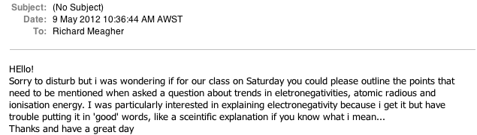

How to answer section 2 and 3 questions